Name _____________________________________________ Birth Date _______________________
Address ___________________________________________ Telephone # _____________________
City ________________________ ST _____ Zip ___________ Email ______________________
Occupation _________________________________________
Emergency Phone Contact: Name: __________________________________Phone: _______________
How did you learn about me? ____________________________________________________________
Have you received Massage Therapy or Bodywork before? _________ What Kinds? ________________

How often? __________________________________________________________________________
Are you on any medication? _______ If yes, which ones? _____________________________________
Do you exercise? _____ How many times per week? _____ For how long? ________________________
Please list and explain other conditions/symptoms you are or have experienced:
___________________________________________________________________________________
___________________________________________________________________________________
Have you had any serious or chronic illness, operations, or traumatic accidents? ___________________

If yes, please explain: __________________________________________________________________
___________________________________________________________________________________

Prenatal Care Provider/Doctor________________________________ Telephone __________________
May I have permission to contact your Care Provider? ________ My due date is_______________.
This is my _________ (number 1st, 2nd, etc.) pregnancy. This will be my______ (number 1st, 2nd…) birth.
I am ____(number) weeks pregnant in my ____ (1st, 2nd, 3rd) trimester
Please check (√ ) current problems, mark with (+) if you had in the past :
___ anemia  ___ leaking amniotic fluid *  ___ bladder infection *  ___ uterine bleeding *  ___ blood clot or phlebitis *  ___ chronic hypertension *  ___ abdominal cramping *  ___ diabetes (gestational or mellitus)  ___ edema/swelling  ___ fatigue  ___ headaches  ___ insomnia  ___ high blood pressure *  ___ leg cramps  ___ miscarriage *  ___ nausea  ___ problems with placenta *  ___ pre-term labor * | ___ sciatica  ___ separation of the rectus muscles  ___ separation of the symphysis pubis  ___ skin disorders/ athletes foot  ___ twins or more! *  ___ varicose veins  ___ visual disturbances *  ___ previous cesarean birth  ___ contagious conditions  ___ muscle sprain / strain  ___ heart attack / stroke  ___ arthritis  ___ carpal tunnel syndrome  ___ allergy to nut oils  ___ low blood pressure  ___ bursitis  ___ hypo or hyperglycemia  ___ contact lens
___ preeclampsia (toxemia) *
___ other conditions or problems in current or past pregnancy___________________________________

____________________________________________________________________________________

Anything else you would like me to know? __________________________________________________

____________________________________________________________________________________

I am experiencing a low risk / high risk (circle one) pregnancy according to my doctor/midwife. If I am currently having or develop complications (any conditions/symptoms listed above with *) I will discuss the condition with my massage therapist, and will have a medical release for bodywork signed by my prenatal care provider before continuing bodywork.
I have completed this health form to the best of my knowledge. I understand that Bodywork is a health aid and does not take the place of a physician's care. Any information exchanged during a Massage or Bodywork session is confidential and is only used to provide you with the best health care services.
If I am not able to make a scheduled appointment, I agree to cancel the appointment 24 hours in advance. If I miss a scheduled appointment without giving 24-hour notice, I agree to pay any missed appointment charge.
I am responsible to pay for any Massage or Bodywork fees not paid for by my insurance company.
Name (signature) _________________________________________ Date _____________________ Circle areas of complaint (if any).
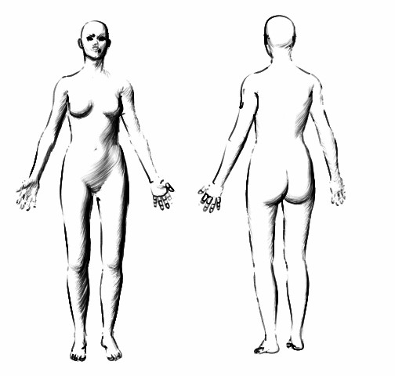

Practitioner Notes:

